## **Step-by-Step Jenkins Setup for Your Project**

Your project contains two parts:

* frontend
* backend

### **1. Start Your Project Locally (for testing)**

#### **Frontend**

cd frontend

npx http-server -p 5555

#### **Backend**

cd backend

npm run start

Make sure both are running fine.

### **2. Ensure Jenkins Is Running**

* Open Jenkins in your browser:  
   [http://localhost:8080](http://localhost:8080/)

### **3. Create Jenkinsfile in your project root folder**

Paste this content into the file:

pipeline {

agent any

environment {

HOMEPATH = "C:\\Users\\Administrator"

PM2 = "C:\\Users\\Administrator\\AppData\\Roaming\\npm\\pm2.cmd" // Update path if needed

}

stages {

stage('Install Dependencies') {

steps {

dir('backend') {

bat 'npm install'

}

dir('frontend') {

bat 'npm install -g http-server'

}

}

}

stage('Run Tests') {

steps {

dir('backend') {

bat 'npm test'

}

}

}

stage('Start All Services with PM2') {

steps {

bat '"%PM2%" delete backend || exit 0'

bat '"%PM2%" delete frontend || exit 0'

bat '"%PM2%" start ecosystem.config.js'

}

}

}

post {

always {

bat '"%PM2%" save --force'

echo ' Deployment complete.'

}

}

}

### **4. Create ecosystem.config.js in your project root**

Paste this content into it:

module.exports = {

apps: [

{

name: "backend",

script: "app.js",

cwd: "./backend",

env: {

PORT: 8080

},

windowsHide: true

},

{

name: "frontend",

script: "cmd.exe",

args: "/c npx http-server -p 8081",

cwd: "./frontend",

interpreter: "none",

windowsHide: true,

out_file: "./logs/frontend3.log",

error_file: "./logs/frontend3-error.log",

log_date_format: "YYYY-MM-DD HH:mm Z"

}

]

};

### **5. Install PM2 Globally (if not already)**

Run this from any terminal:

npm install -g pm2

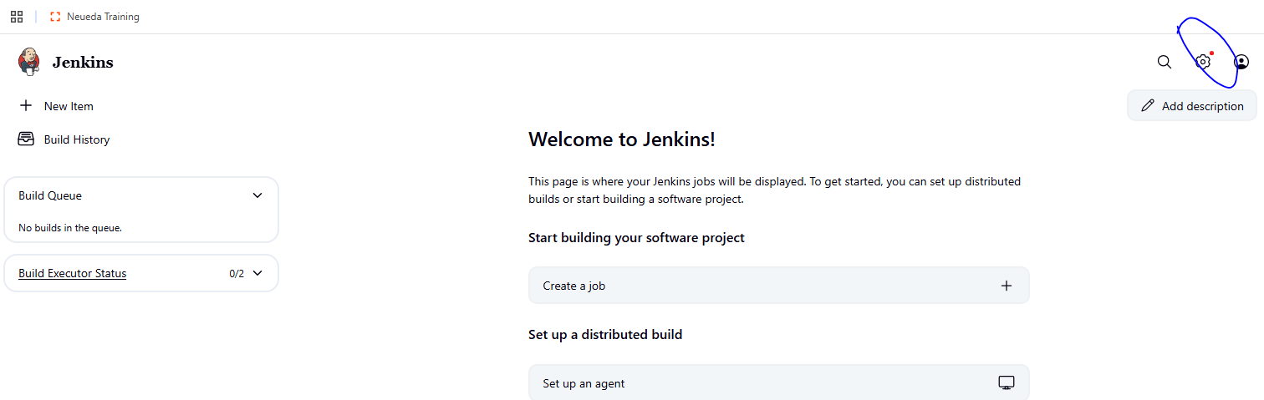

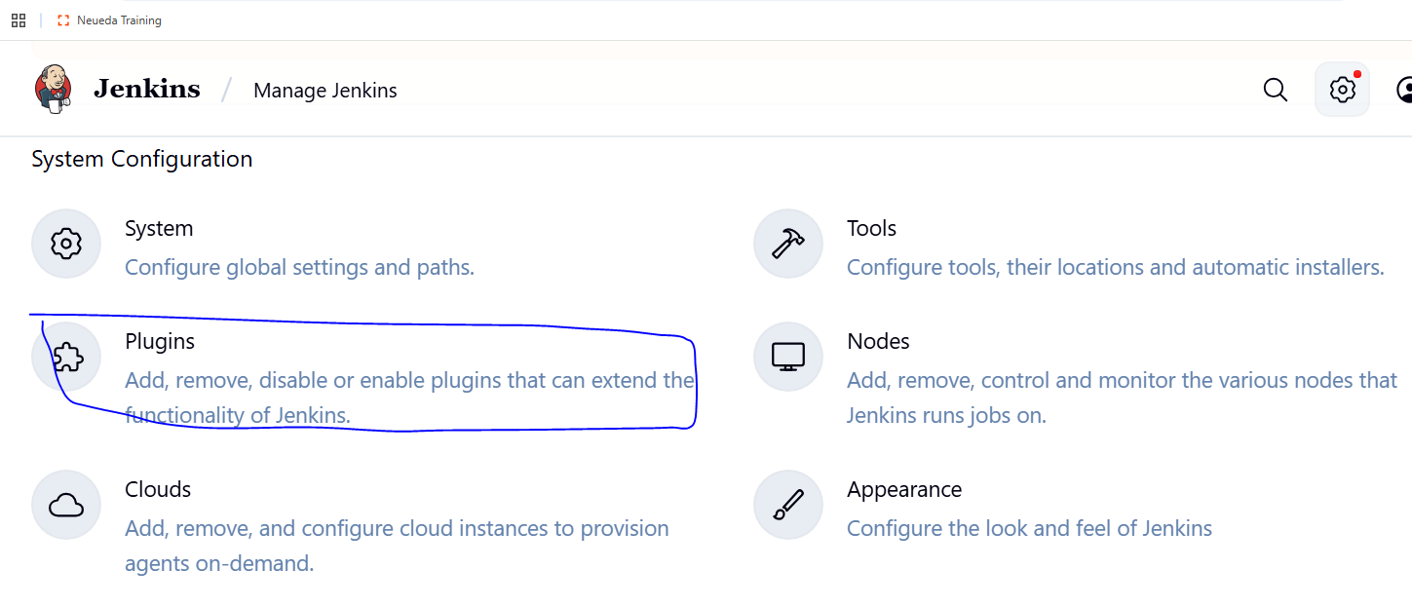

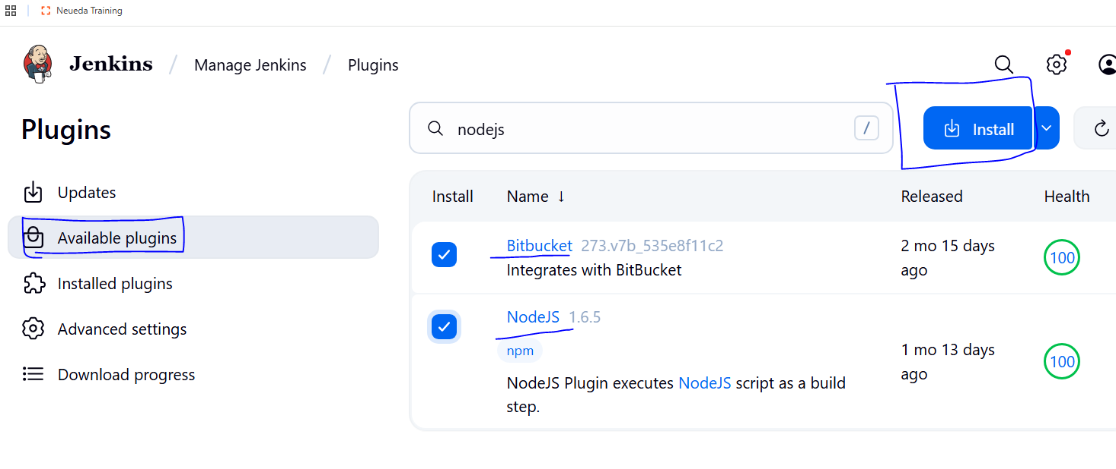

## **1. Open Jenkins**

* Open your browser and go to:  
   [**http://localhost:8080**](http://localhost:8080/) (If Jenkins is on another server, replace localhost with that server’s IP or domain.)

## **2. Login to Jenkins**

* **Default Username:** admin (or the one you created during setup).
* **Default Password:**
  + Check the file:  
     C:\Program Files (x86)\Jenkins\secrets\initialAdminPassword  
     (on Windows)  
     or  
     /var/lib/jenkins/secrets/initialAdminPassword (on Linux).
  + Copy the password from the file.
* Paste it into the login screen and continue.

## **3. Go to Manage Jenkins**

* From the Jenkins dashboard, click:  
   **"Manage Jenkins"** → **"Plugins"** (or **"Manage Plugins"**).

## **4. Install NodeJS Plugin**

1. In **Manage Plugins**, go to **Available** tab.
2. Search for **NodeJS**.
3. Check the box next to **NodeJS Plugin**.
4. Click **Install without restart**.

## **5. Install Bitbucket Plugin**

1. In the same **Available** tab, search for **Bitbucket**.
2. Check the box next to **Bitbucket Plugin** (or **Bitbucket Branch Source** if needed).
3. Click **Install without restart**.

## **6. Configure NodeJS in Jenkins**

1. Go to **Manage Jenkins → Global Tool Configuration**.
2. Scroll to **NodeJS**.
3. Click **Add NodeJS**, give it a name like node16 or node18.
4. Select **"Install automatically"** and choose a NodeJS version.
5. Save.

## **7. Connect Jenkins to Bitbucket**

1. Go to your Jenkins job (or create a new **Pipeline** job).
2. Under **Source Code Management**, select **Git**.
3. Paste your **Bitbucket repository URL**.
4. Add credentials (Bitbucket username/password or SSH key).
5. Save.

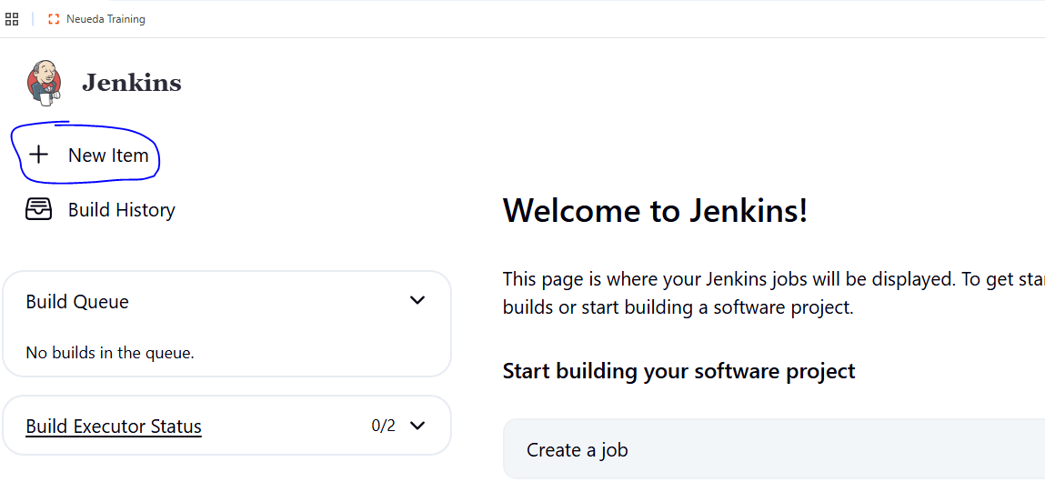

### **Create a New Item**

* Click on **“New Item”** (left side).
* Enter a **name** for your project, e.g., NodeAppPipeline.
* Select **"Pipeline"** (scroll down to find it).
* Click **OK**.

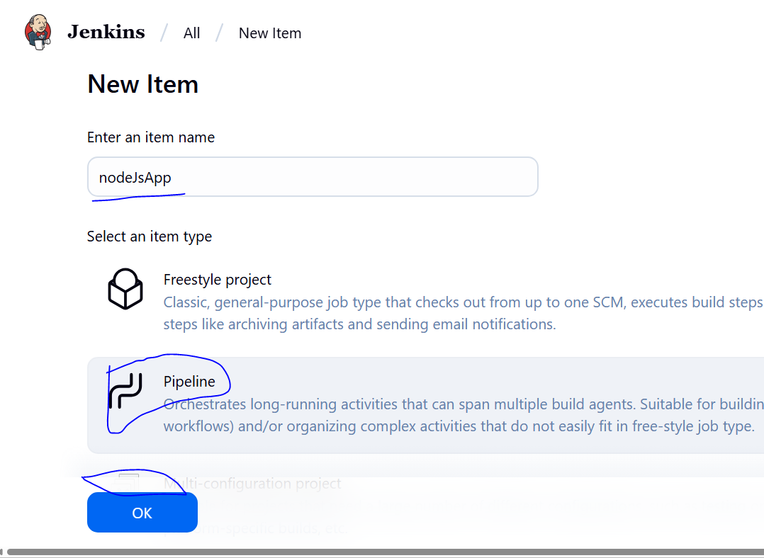

## **Enable Build Trigger from Bitbucket in Jenkins**

### **Step 1: Open Your Pipeline Job**

* Go to Jenkins Dashboard → Click your **Pipeline job** (e.g., NodeAppPipeline).
* Click **Configure** (left side).

### **Step 2: Enable Bitbucket Trigger**

Scroll down to the **“Build Triggers”** section.

* Check **"Build when a change is pushed to Bitbucket"**

This option appears only if **Bitbucket Plugin** is installed.

**Step 3: Add Bitbucket Repository URL**

* Scroll to the **Pipeline** section.
* Under **Pipeline script from SCM**, set:  
  + **SCM**: Git

**Repository URL**:  
 e.g.,  
  
 https://bitbucket.org/your-username/your-repo-name.git

### **Setup Webhook in Bitbucket (Important)**

Go to **Bitbucket**:

1. Open your repository → **Settings**
2. Go to **Webhooks** → Click **“Add Webhook”**
3. Enter:  
   * **Title**: Jenkins Webhook

**URL**:  
  
 http://<your-jenkins-ip>:8080/bitbucket-hook/ [GET YOUR OWN IP ADDRESS] PUBLIC IP

* + Example:  
     http://localhost:8080/bitbucket-hook/ if Jenkins is local.

1. **Triggers** → Select **Repository Push**
2. Save

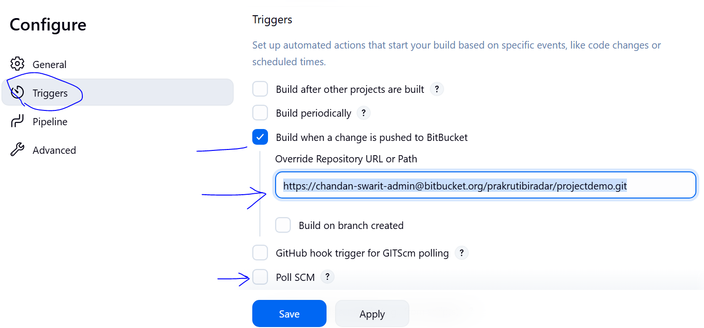

### **Go to Your Pipeline Job**

* From the Jenkins Dashboard, click on your job (e.g., NodeAppPipeline)
* Click **Configure**

### **Scroll to Pipeline Section**

Under the **Pipeline** block:

#### **Select:**

* **Definition**: Pipeline script from SCM
* **SCM**: Git

**Add Bitbucket Repository URL**

In **Repository URL**, paste your Bitbucket repo:

https://bitbucket.org/<your-username>/<your-repo-name>.git

Example:

https://bitbucket.org/johndoe/my-node-app.git

**Add Bitbucket Credentials (App Password Method)**

1. Click **Add → Jenkins**
2. In the popup:  
   * **Kind**: Username with password
   * **Username**: your Bitbucket username
   * **Password**: your Bitbucket **App Password**
   * **ID**: (optional) can be left blank or give a name like bitbucket-creds
   * **Description**: e.g., "Bitbucket App Password"
3. Click **Add**
4. Now in the **Credentials** dropdown, select the one you just added.

**Specify Branch**

**Branches to build**:  
  
 */main

or  
  
 */master

Use whatever your default branch name is in Bitbucket.

**Script Path**

Jenkinsfile

Ensure your Jenkinsfile is in the root of the repo.

### **Save the Pipeline**

* Click **Save**

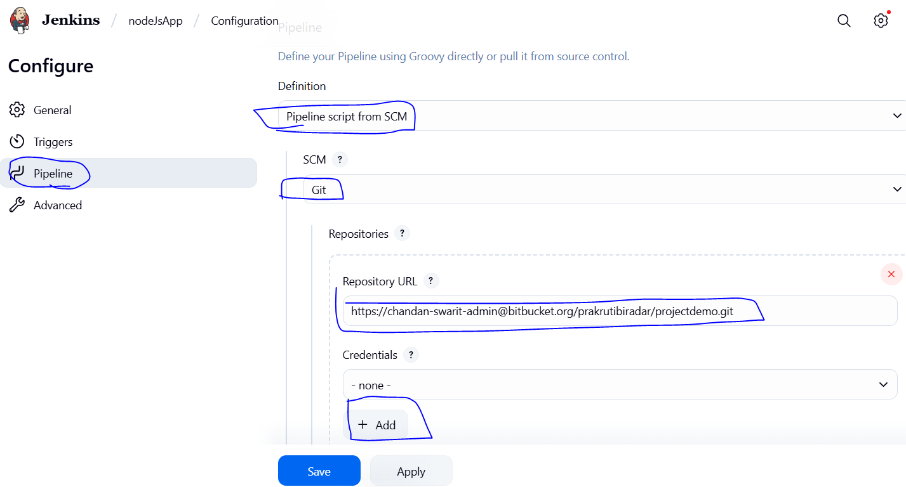

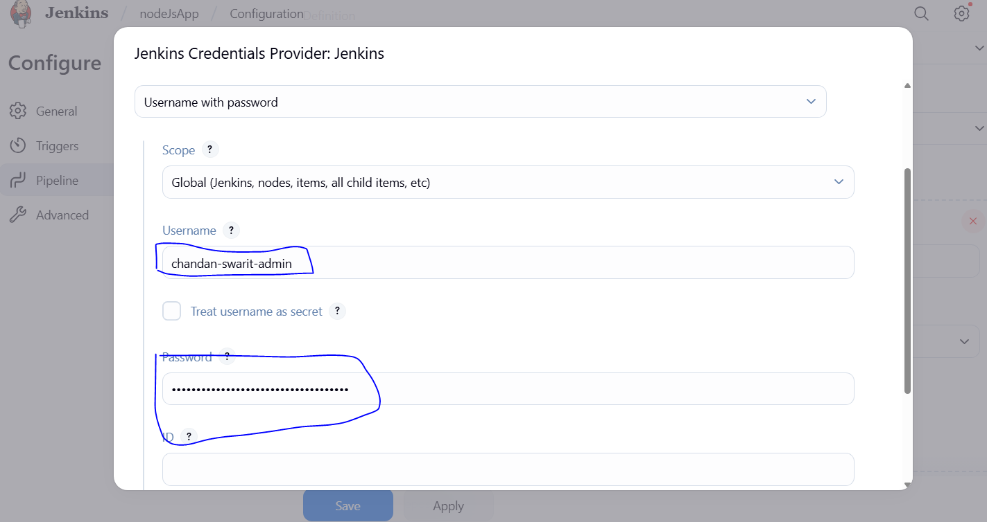

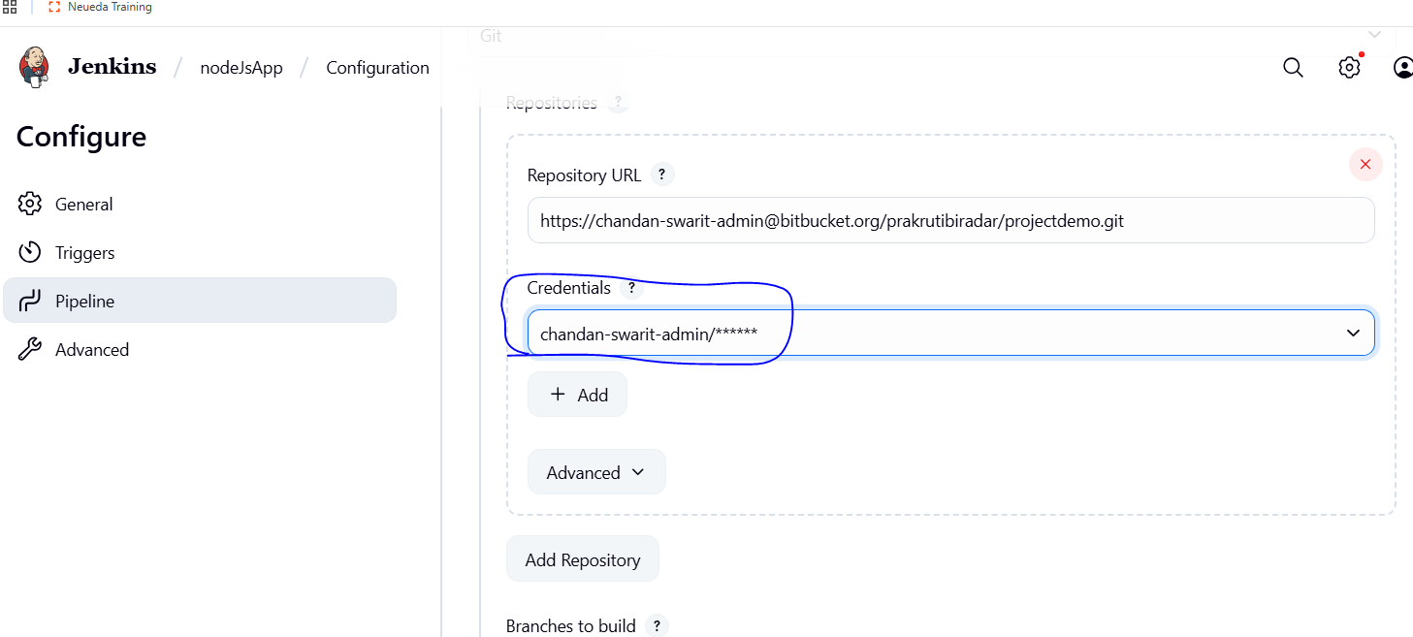

Apply and save changes

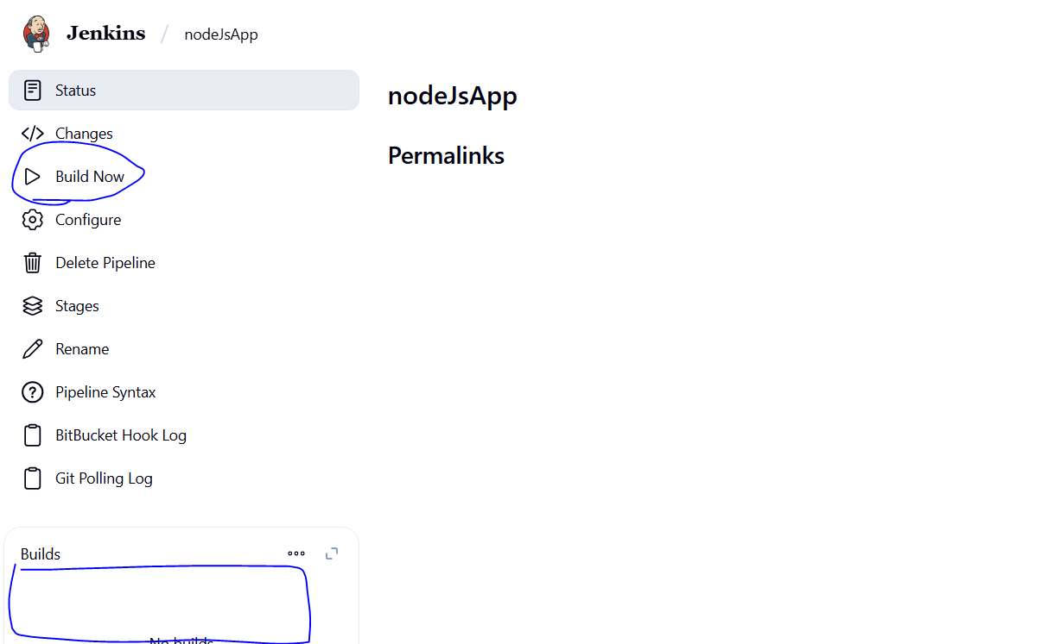

### **Click "Build Now"**

* Go to your **Pipeline Job** in Jenkins (e.g., NodeAppPipeline)
* On the **left panel**, click **"Build Now"**

### **Watch the Build Start**

* A build number (e.g., #1) will appear under **Build History** (left side).
* You’ll see a progress bar (blue/green if okay, red if failed).

### **Read Console Output**

* Click on the build number (e.g., #1)
* Then click **“Console Output”  
   Look for Errors or Confirm Success**

#### **🔹 If successful:**

You’ll see messages like:

[Pipeline] echo

✅ Deployment complete.

Finished: SUCCESS

#### **🔹 If error:**

You might see messages like:

npm ERR! code ENOENT

npm ERR! missing script: start

FATAL: pm2 is not recognized as an internal or external command

ERROR: Cannot find module 'http-server'

fatal: could not read Username for 'https://bitbucket.org': No such device or address

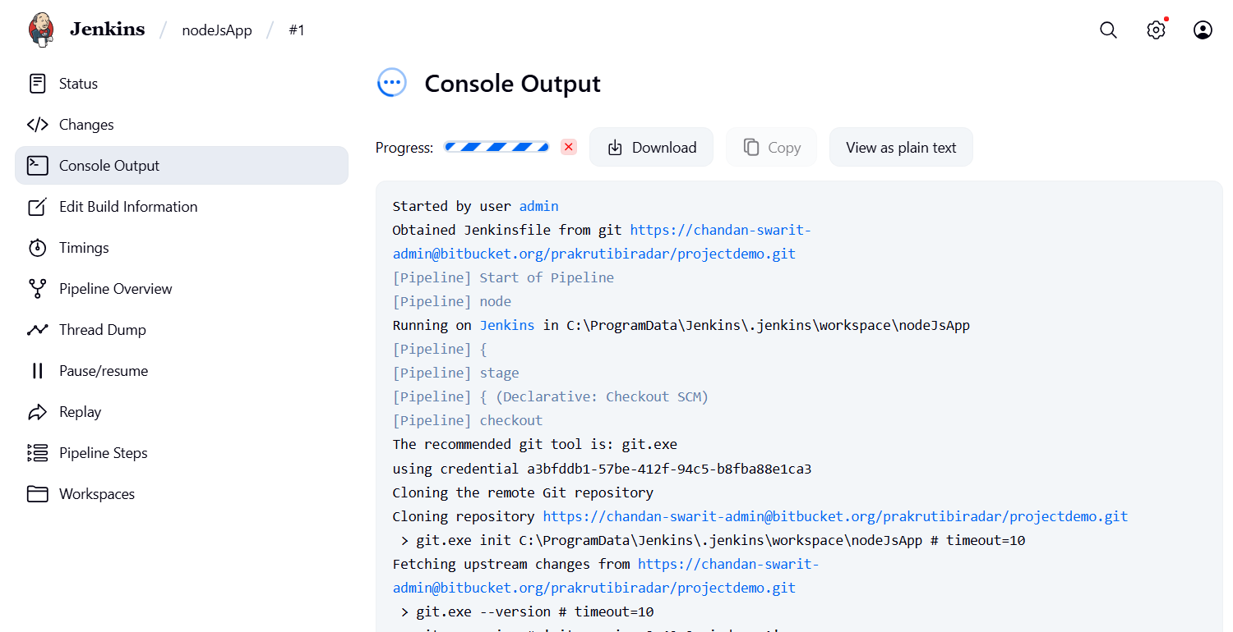

Bitbucker, repo, report settings

